CMPT 371 Assignment 3 Wireshark Lab Zhixin Huang 301326521

1. IP address: 192.168.1.102

TCP port: 1161

1. IP address: 128.119.245.12

TCP port: 80



1. IP address: 192.168.1.18

TCP port: 1191

1. Sequence number is 0. SYN flag is set to 1.
2. The sequence number of the SYNACK segment is 0. The value of the Acknowledgement field in the SYNACK segment is 1. gaia.cs.umass.edu determine that value by adding one to the sequence number of the SYNACK segment. Acknowledgment and syn flags are set to 1 to identifies the segment as a SYNACK segment.
3. The sequence number of the TCP segment containing the HTTP POST command is 1.

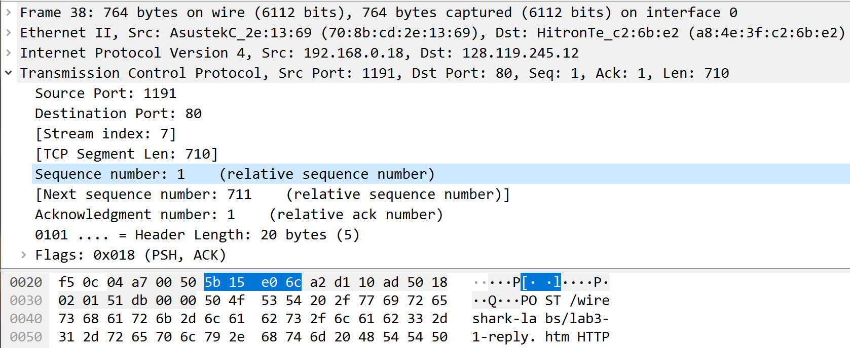

1. The sequence numbers of the first six segments are 1; 711; 2171; 3631; 5091; 6551

|  |  |  |  |  |
| --- | --- | --- | --- | --- |
| segments | sequence number | sent | ACK | RTT |
| 1 | 1 | 1.994511 | 1.994929 |  |
| 2 | 711 | 1.994608 | 2.080144 |  |
| 3 | 2171 | 1.994609 |  |  |
| 4 | 3631 | 1.994610 |  |  |
| 5 | 5091 | 1.994610 |  |  |
| 6 | 6551 | 1.994610 |  |  |